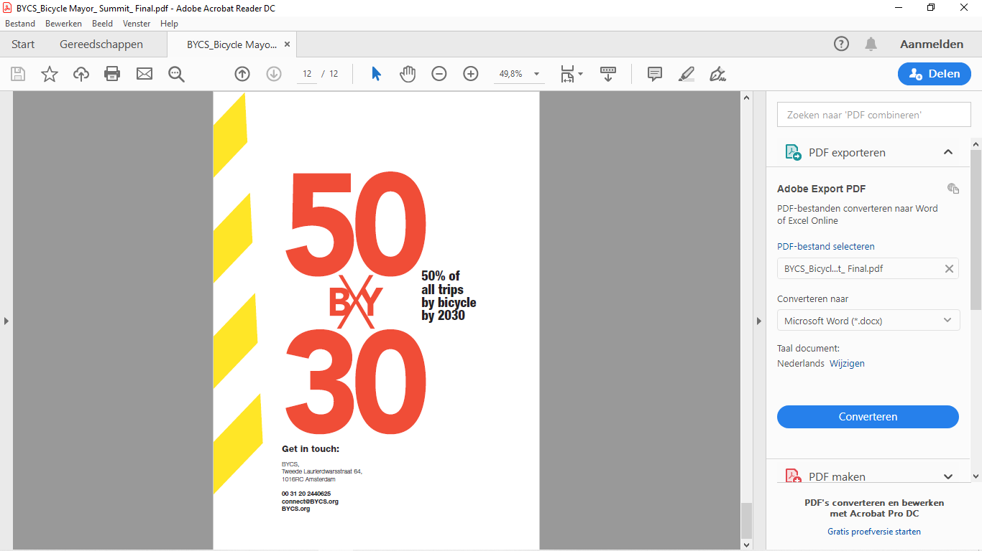
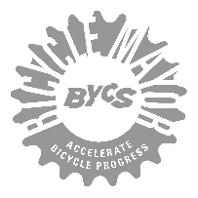
Project Name: Bicycle Bus Pilot in Waterloo | Date: August 24, 2023
Lead Parent: Scott Weldon | Project Supporter: Arcy Canumay, Bicycle Mayor of Waterloo
Version 2.0 (After the bike bus pilot in June 2023)

BIKE BUS PILOT PROJECT IN WATERLOO

- Goals
  - To increase the number of students and parents safely biking to school
  - To increase the activity level of students by biking to school and starting the day with a physical activity that also benefits their overall well-being
  - To decrease the number of parents driving their kids to school
- Benefits
  - The community benefits with more students and parents biking to school which will result in less car traffic and less pollution (Environment)
  - Healthier students and parents who actively bike to school (Health and Well-being)
  - Safer neighbourhood near schools as a result of less vehicle traffic (Safety)
  - Savings for families as a result of lower car-related costs (Lower cost)
- Key Success Factors
  - Safe environment to ride a bike to school
  - Volunteer parents who will lead the BiciBus
  - Support from the school principal and teachers
- Project Resources
  - Planning document (This one)
  - Bike Bus Route map
  - Key contact list - Parents, partners and supporters
  - BiciBus Kit, now available in English
- Project Phase and Time Frame
  - Phase 1: Project Planning (Jan - Feb 2023)
  - Phase 2: Reach-out to schools, parents, partners and supporters ( Feb - Apr 2023)
  - Phase 3: Identify pilot school and discuss with parents (Apr 2023)
  - Phase 4: Prepare for launch (Apr - May 2023)
  - Phase 5: Bike Bus in Waterloo Pilot Launch (June 1, 2023)
- Partners and Supporters
  - Empire Public School
  - Student Transportation Services of Waterloo Region (STSWR)
  - City of Waterloo
  - Bicycle Mayor of Waterloo

SHARING OUR EXPERIENCE AND LEARNINGS

BIKE BUS INFORMATION
- School: Empire Public School in Waterloo, ON
- Start Date: Thursday, June 1st (Because Friday, June 2nd was a PA day)
- Inclusive Dates: Friday, June 9th and 16th
- Last Ride Date: Friday, June 23rd

BIKE BUS SAFETY
Safety of all Bike Bus participants are the top priority of this initiative. Below are the key actions taken by the organisers to ensure the safety of all participants in the Bike Bus:
- Scott, our parent lead for the project is an experienced cyclist with many years of riding his bike in Waterloo Region and other places in Canada. He and his family live in the neighbourhood where the bike bus route will go through. He identified a safe route that will enable the Bike Bus to pick up more riders. Arcy created the digital version of this route on Google My Maps. (Key Learning: Parent leading the bike bus who is an experienced cyclist + lives in the neighbourhood in the bike bus route + identified the safe route)
- About 3 weeks before the target start, Scott and Arcy rode the route and discussed busy intersections and areas to watch out for. An example of a busy intersection was William St and Dunbar Rd. This was identified and key actions were taken to ensure the safety of the bike bus while crossing this intersection.
- On May 26th, we did a “dry run” of the bike bus route with a few volunteer parents and their kids. We introduced the safety marshall role to the parents and asked for volunteers. It was later renamed to safety patrol by the kids and they undertake the following activities:
  - Wear a hi-vis safety vest
  - Lead patrol: Position in front of the bike bus, lead the ride while watching for incoming cars and double-check intersections. Slowest riders will be behind the lead patrol to set the pace of the bike bus.
  - Left patrol: Position to the left of the bike bus more or less in the middle of the pack. Ride on the middle portion of the road and ensure that all other riders are to the right. Will need to speed up as the bike bus approaches a busy intersection (William and Dunbar for example). Check both sides that drivers have visual contact and their cars are stopped. Left marshall will then go on the intersection and signal all traffic to stop. Signal the bike bus to go through.
  - Right patrol: A tricky position because the marshall rides near the curb. Usually rides with the lead marshall then accelerates if the bike bus is approaching a busy intersection. Similar to the left patrol in terms of safety responsibility and actions that need to be taken in crossing intersections.
  - Sweep/Back patrol: Stays at the back of the bike bus. At the start of the ride, count the number of participants (Kids and parents/guardians/adults). Counts the new riders that join the bike bus. Monitors that no riders are left behind. Informs the patrol or parents in the ride to relay a message to the lead marshall to slow down.
  - (Key Learning: The Bike Bus Patrol is very important for the safety of the Bike Bus. If there are only 3 volunteer patrols then the right can be dropped)
BIKE BUS IN ACTION
This next section captures our experience and other learnings in the Bike Bus Pilot. Check it out below:
- Ride 1: Thursday, June 1 - Our plan was to ride every Friday in June until the end of the school year. But since Friday, June 2nd was a PD day (Professional Development for Teachers) and there was no class, we scheduled the ride a day early. It works out really well because it is also the start of Bike Month in Canada! (18 kids / 6 parents and volunteers)
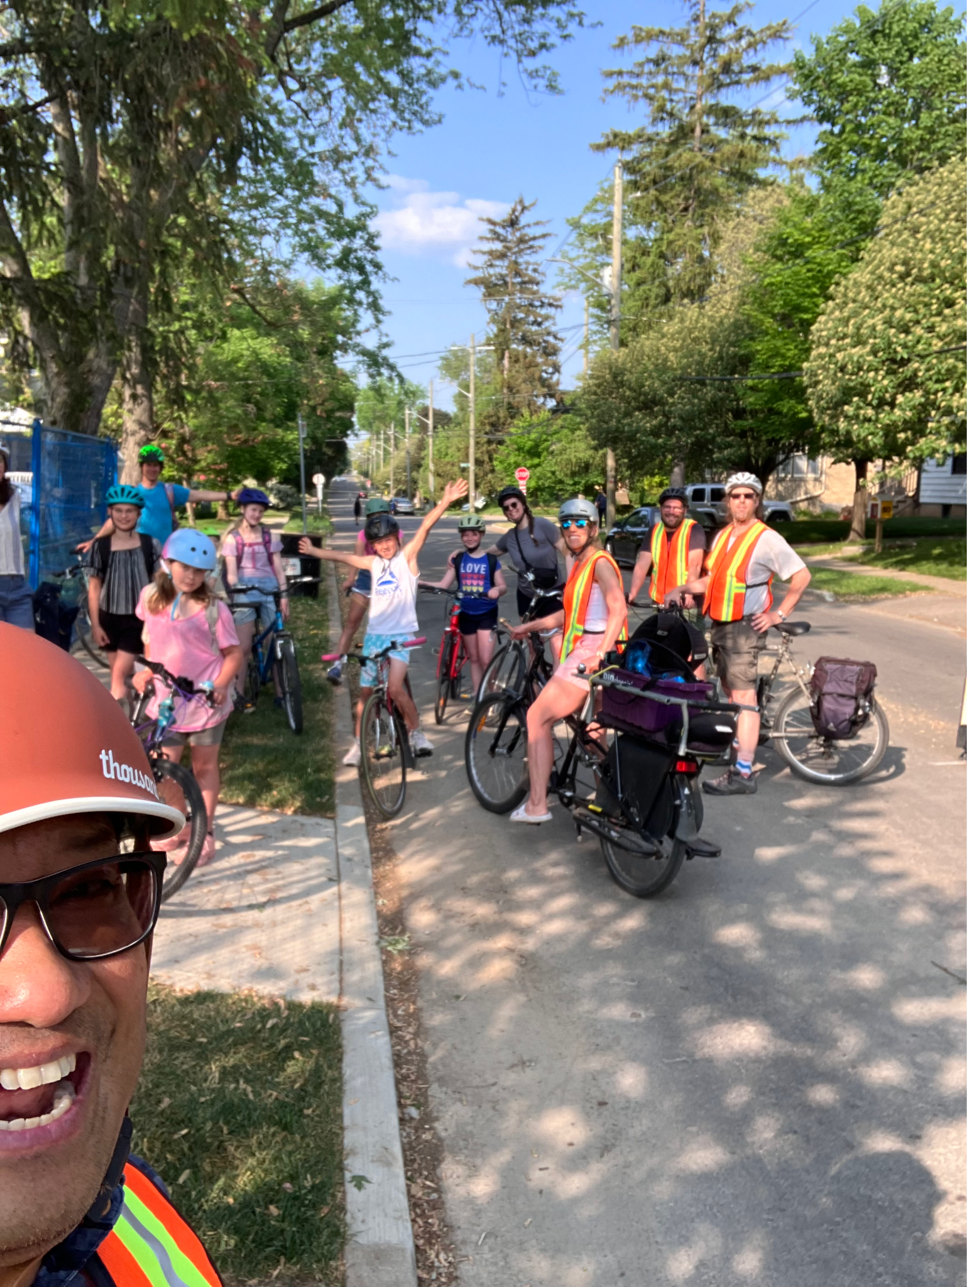
- Ride 2: Friday, June 9 - After a successful first Bike Bus ride we had more kids and volunteer parents who joined us. (Key Learning: The kids who joined the first ride spread the word about how fun riding with the Bike Bus. They encouraged kids they knew who were walking to join us for the next ride) (20 kids / 7 parents and volunteers)
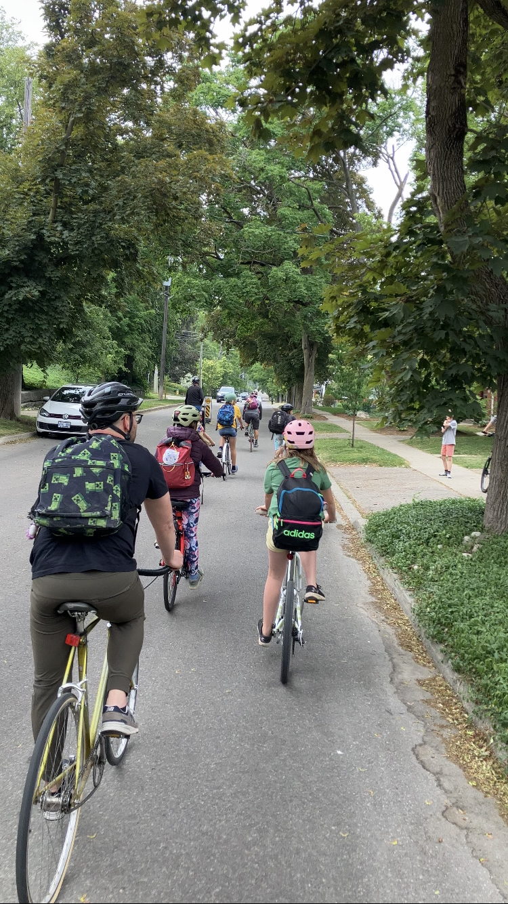

- Ride 3: Friday, June 16 - The patrols are becoming more familiar with their roles and some of them were assigned a different position in the Bike Bus Patrol formation 🙂 The school reached out to one of our parent patrols for the Bike Bus to be featured in the end-of-school year newsletter. (Key Learning: We had 6 regular Bike Bus Patrol volunteers and assigning them to different roles enabled us to be flexible when someone was not available. We had 4 patrol volunteers who were able to lead the ride and the rest can comfortably handle being the back or left/right patrol) (25 kids / 8 parents and volunteers)
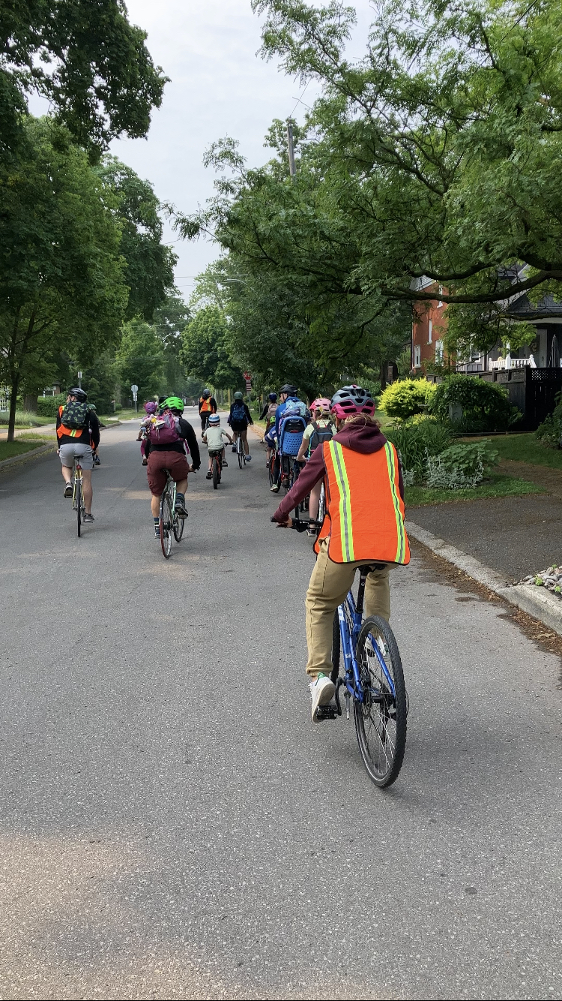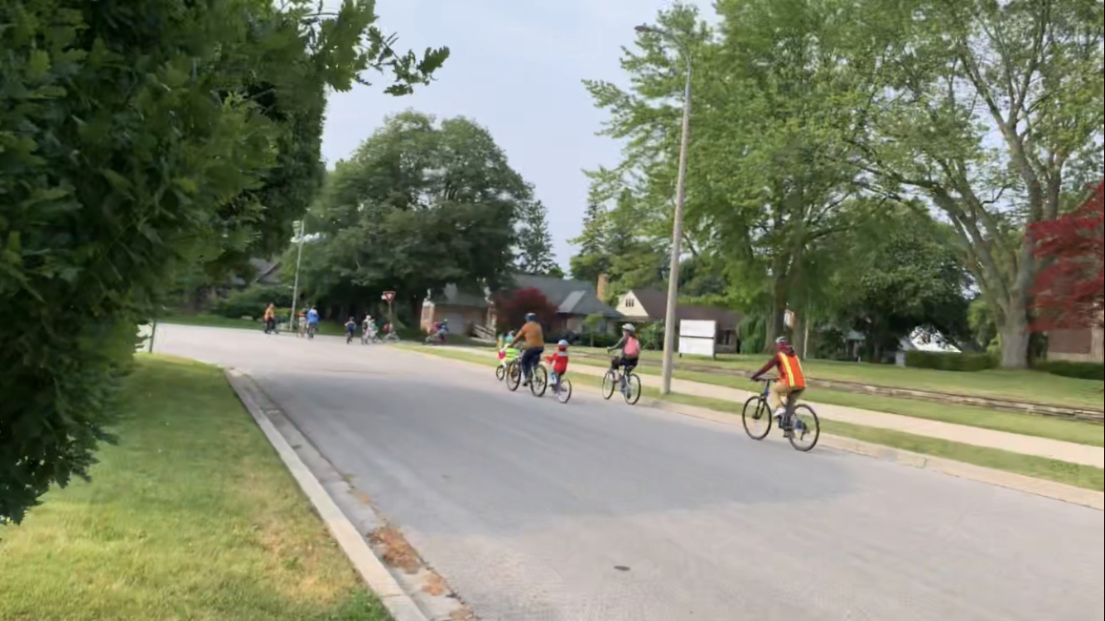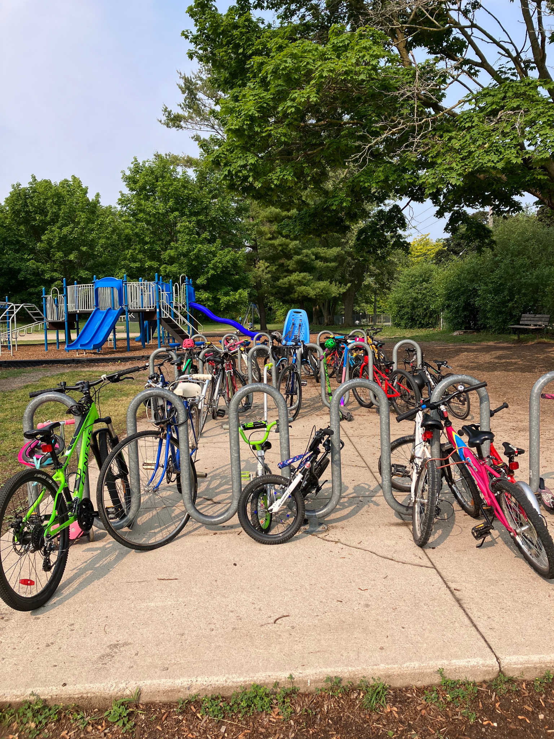
- Ride 4: Friday, June 23 - The Bike Bus was almost full for our last ride of the school year 😉 We had 3 guests who joined us, Dorothy McCabe (Mayor of Waterloo), Leslie Maxwell (Student Transportation Services of Waterloo Region) and Mark Connelly (Cycling Guide App). We invited them to see first hand and experience the safe and fun way the Bike Bus goes to school. (Key Learning: The kids who joined the first ride spread the word about how fun riding with the Bike Bus. They encouraged kids they knew who were walking to join us for the next ride) (34 kids / 8 parents and volunteers / 3 guests)
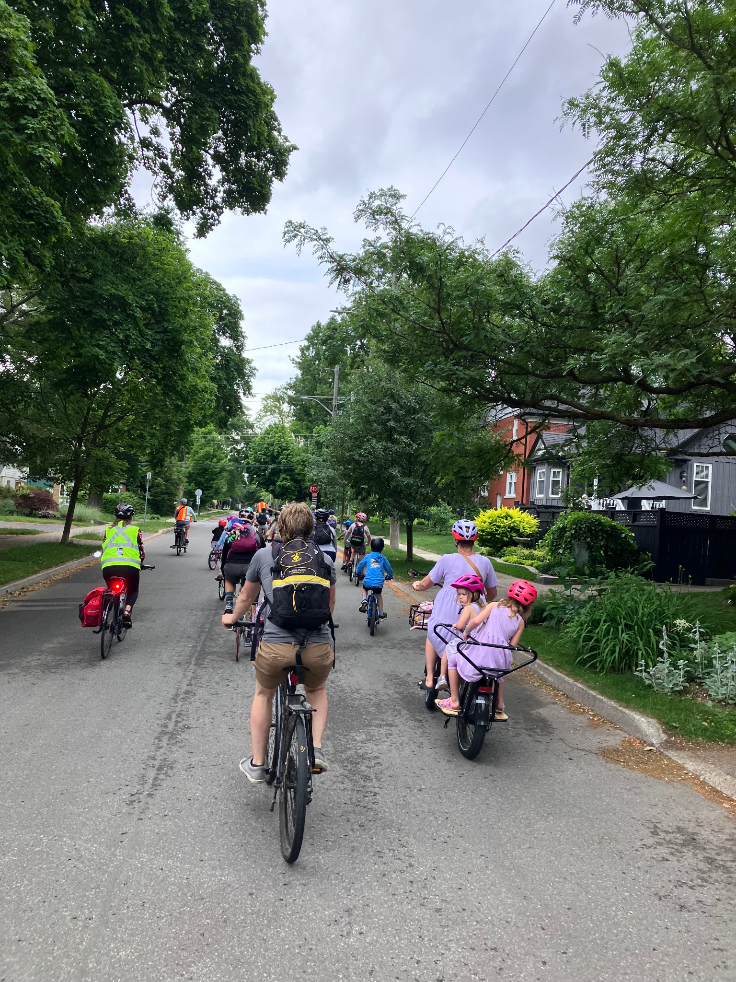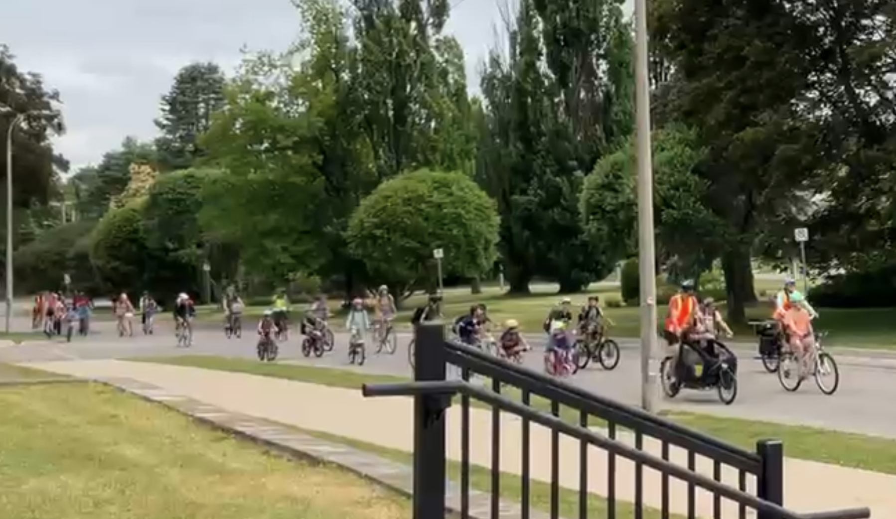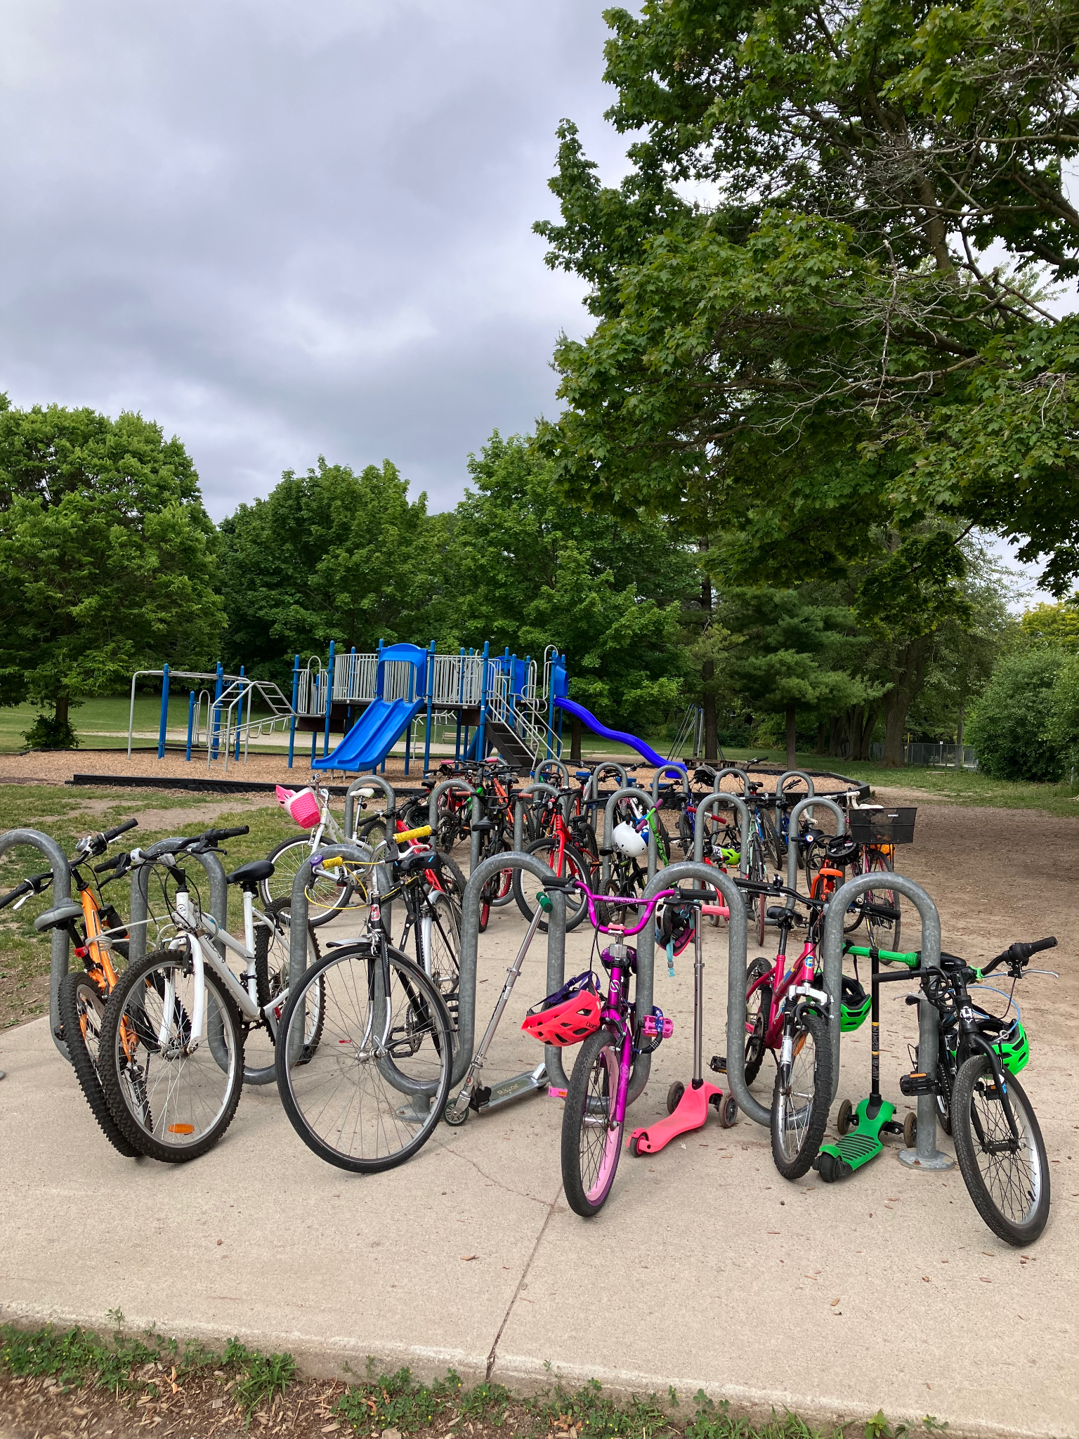

Other learnings and tips for other would be Bike Bus organisers:
- Our Bike Bus was a parent-led initiative. You will have a better chance to get your Bike Bus running if it is run by parents.
- It is important to have a parent who regularly bikes around the neighbourhood or city/town to be involved in planning a safe route.
- Get the kids involved in planning the Bike Bus and get their feedback on how it can be improved. Encourage them to promote the Bike Bus to their friends and classmates.
- Welcome all modes of active transportation! Aside from kids cycling, we had a kid who ran to school and some kids who rode their scooter to school. The kid who ran finally rode his bike during our final ride in June 2023 🙂

Feel free to reach out if you have any Bike Bus questions:
- Scott Weldon - s_weldon@hotmail.com
- Arcy Canumay - arcy.canumay@gmail.com | bikemayorwat@gmail.com

